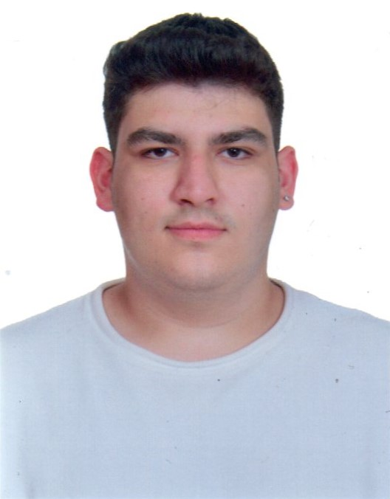

**EFE TAHA KOCAS**

**IT SUPPORT SPECIALIST**  
GAZIOSMANPAŞA / ISTANBUL  
efe_yedek@hotmail.com  
+90 541 957 6896

# SUMMARY

I am a Computer Programming graduate who has had the opportunity to apply theoretical knowledge gained during my education in real work environments. At the Helpdesk unit of Beşiktaş Municipality IT Department, I actively participated in system support and troubleshooting user issues. While working in the technical support team at Beymen, I gained experience in resolving problems and managing hardware within corporate infrastructures. At Setup Maint, I further developed my skills by working on technology-focused projects involving different systems. Additionally, I have practical experience in software development through various projects such as game development with Unity, image processing and artificial intelligence applications using Python, and building React-based e-commerce systems. I am responsible, solution-oriented, and work well in teams. My goal is to take an active role in corporate technology projects, enhance my experience, and make lasting contributions to the industry.

# EDUCATION

**Beykent University – Istanbul, Turkey (2023–2025)**  
Computer Programming | Graduated: 2025

**Şafak Schools – Istanbul, Turkey**  
High School Diploma in Electrical and Electronics | Graduated: 2023

# WORK EXPERIENCE

**SETUP MAINT – IT SUPPORT INTERN**  
**September 2022 – December 2022 (Istanbul)**

* Installed and configured software and hardware depending on availability and requirements.
* Assisted in setting up and maintaining IT infrastructure across different systems.
* Gained initial hands-on experience in IT support and system installation.

**BEYMEN GROUP – IT SUPPORT INTERN**  
**December 2022 – June 2023 (Istanbul)**

* Provided helpdesk support and resolved users’ technical issues.
* Gained experience in the retail and fashion industry, working in a fast-paced, customer-focused environment.
* Supported system users while adhering to corporate IT policies and procedures.
* Assisted in maintaining IT infrastructure and responding to daily technical requests.

**BEŞIKTAŞ MUNICIPALITY – IT SUPPORT INTERN  
June 2025 – August 2025 (Istanbul)**

* Delivered user support while following municipal IT procedures and documentation standards.
* Installed additional software and hardware based on user and department needs.
* Participated in troubleshooting and system updates in a public sector IT environment.

# KEY SKILLS

* Helpdesk Support
* Printer and Peripheral Device Installation
* IT Inventory and Documentation Tracking
* MS Office Programs
* Windows Operating Systems (7, 10, 11, Server)
* Network Configuration (LAN/WAN, IP, DHCP, DNS)
* Customer-Oriented Problem Solving
* Teamwork and Communication Skills
* Programming Languages
* Web Development
* Database Management
* Software & Tools
* Use of Visual Tools
* Hardware Knowledge

# LANGUAGES

* Turkish (Native)
* English (B1)

**ADDITIONAL INFORMATİON**

* **Driver’s License:** Class B (Active Driver)
* **Military Status:** Postponed
* **References:** Available upon request
* **Travel Availability:** No travel restrictions
* **Working Hours:** Flexible with working hours